

**A211 STIA1113 PROGRAMMING 1 (GROUP C)**

LECTURER : Prof. Madya Dr. Azman B Yasin

NAME : Muhamad Aimil Daniel Bin Latif

MATRIC NUMBER : 287056

TOPIC : Bank

SUBTOPIC : Investment

1. **Identify the Problem**

An asset or object purchased with the intention of generating income or appreciation is referred to as an investment. The term "appreciation" refers to an asset's value increasing over time. When a person buys something as an investment, the goal is not to consume it but to utilise it to build wealth in the future. The purpose of investing is to generate income and increase the value of an asset over time. Any technique for earning future revenue might be referred to as an investment. This involves, for example, the acquisition of bonds, stocks, or real estate property. Buying a property that can be used to manufacture things may also be considered an investment.

In general, any action that is taken in the hopes of raising future revenue can also be considered an investment. For example, when [choosing to pursue additional education](https://www.investopedia.com/articles/basics/11/3-s-simple-investing.asp), the goal is often to increase knowledge and improve skills (in the hopes of ultimately producing more income). Because investing is oriented toward the potential for future growth or income, there is always a certain level of risk associated with an investment. An investment may not generate any income, or may actually lose value over time. For example, it's also a possibility that you will invest in a company that ends up going bankrupt or a project that fails to materialize. This is the primary way that saving can be differentiated from investing: saving is accumulating money for future use and entails no risk, whereas investment is the act of leveraging money for a potential future gain and it entails some risk.

There are four main investment types which are growth investment, shares, property, defensive investments, cash and fixed interest. Growth investments are more suitable for long term investors that are willing and able to withstand market ups and downs. Shares are considered a growth investment as they can help grow the value of your original investment over the medium to long term. If you own shares, you may also receive income from dividends, which are effectively a portion of a company’s profit paid out to its shareholders. Of course, the value of shares may also fall below the price you pay for them. Prices can be volatile from day to day and shares are generally best suited to long term investors, who are comfortable withstanding these ups and downs. Also known as equities, shares have historically delivered higher returns than other assets, shares are considered one of the riskiest types of investment. Property is also considered as a growth investment because the price of houses and other properties can rise substantially over a medium to long term period. However, just like shares, property can also fall in value and carries the risk of losses. It is possible to invest directly by buying a property but also indirectly, through a property investment fund. For defensive investments, these are more focused on consistently generating income, rather than growth, and are considered lower risk than growth investments. Cash investments include everyday bank accounts, high interest savings accounts and term deposits. They typically carry the lowest potential returns of all the investment types. While they offer no chance of capital growth, they can deliver regular income and can play an important role in protecting wealth and reducing risk in an investment portfolio. The best-known type of fixed interest investments are bonds, which are essentially when governments or companies borrow money from investors and pay them a rate of interest in return. Bonds are also considered as a defensive investment, because they generally offer lower potential returns and lower levels of risk than shares or property. They can also be sold relatively quickly, like cash, although it’s important to note that they are not without the risk of capital losses.

As mentioned, investing is putting money to work in order to grow it. When you invest in stocks or bonds, you are putting that capital to work under the supervision of a firm and its management team. Although there is some risk, that risk is rewarded with a positive expected return in the form of capital gains and/or dividend & interest flows. Cash, on the other hand, will not grow, and may very well lose [buying power](https://www.investopedia.com/terms/b/buyingpower.asp) over time due to inflation. Put simply, without investment, companies would not be able to raise the capital needed to grow the economy.

Since my topic is about investment, I had found that CIMB Islamic Bank Berhad offers many investment products. CIMB Group Holdings Berhad is a Malaysian universal bank headquartered in Kuala Lumpur and operating in high growth economies in ASEAN. CIMB Group is an indigenous ASEAN investment bank and CIMB has a wide retail branch network with 1,080 branches across the region.

So, this are the some types of investment in CIMB Islamic Bank Berhad :

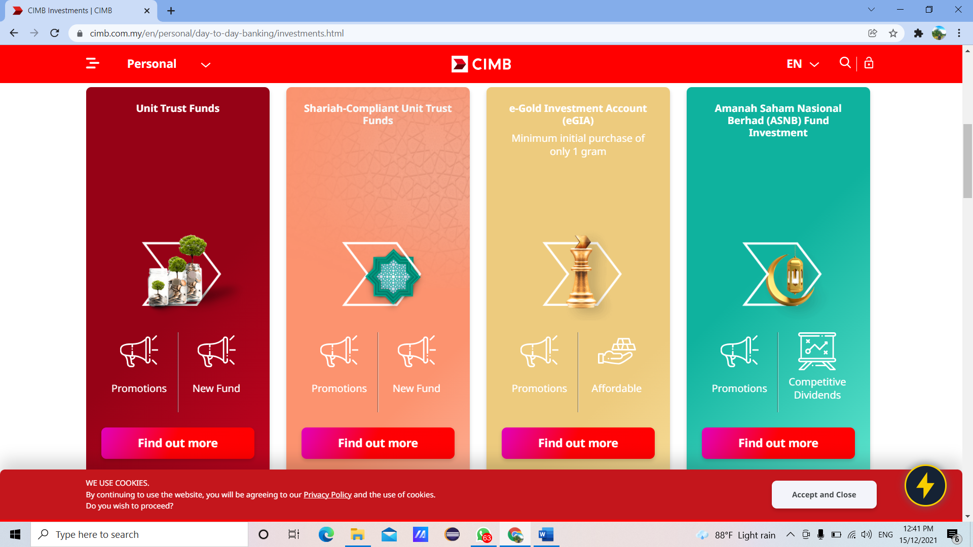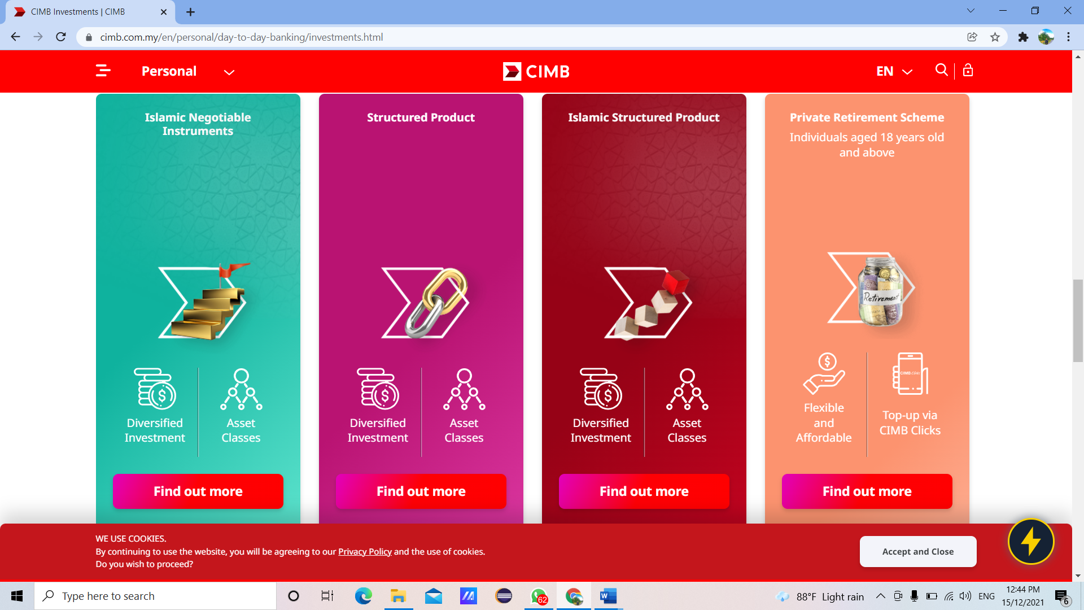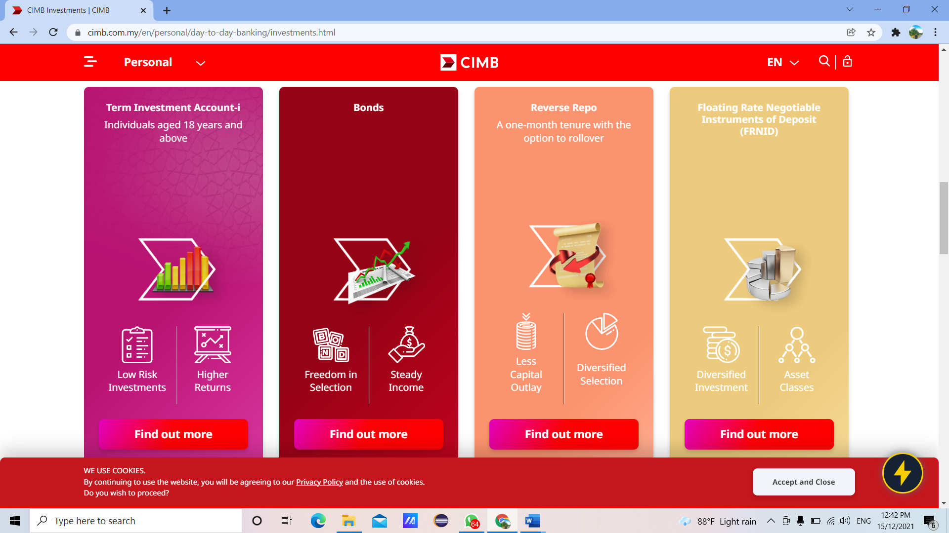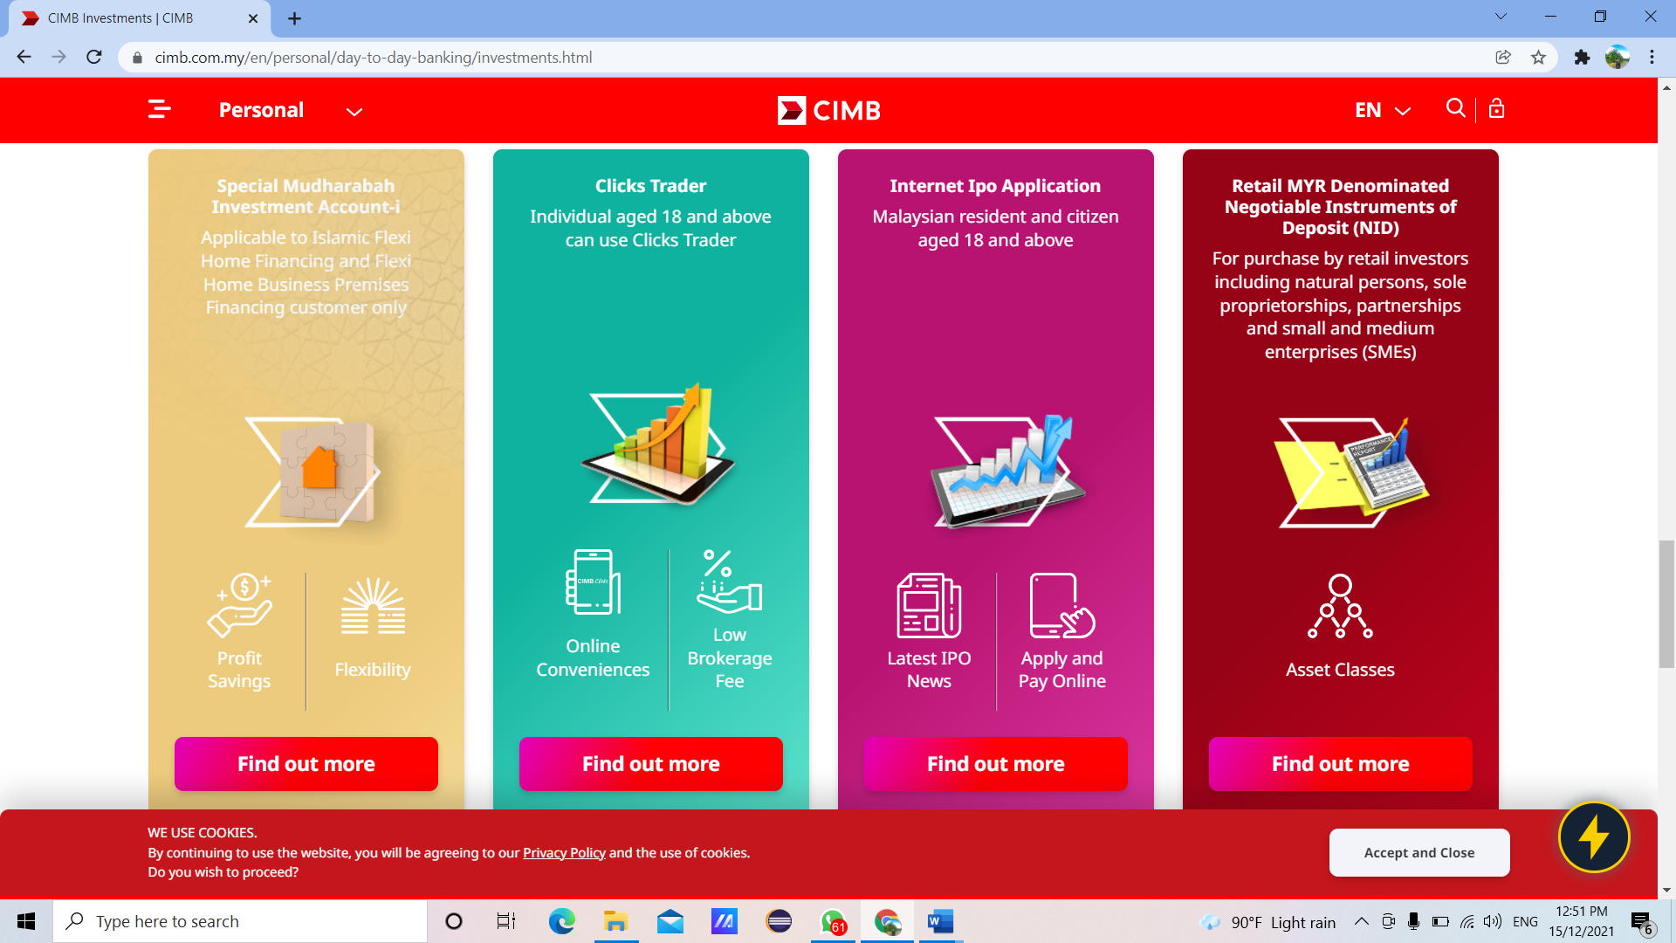 

Now we are living in this pandemic, so some of the residents in Malaysia had to face with financial problem. I would think that the investment suggest by CIMB are the one which can help with this financial problem.

1. **Understand the problem**

The Covid-19 pandemic has affected the income of the population. This has caused the savings to dwindle. So, they're looking for ways to raise their savings. Therefore, CIMB Islamic Bank Berhad has introduced an investment scheme known as Term Investment Account-i. This investment account offers high return potential and no fees. The minimum investment placement per account holder will be RM1,000 for 3, 6- and 12-months tenure for individual. Actual returns will be declared based on the actual performance of the investment. However, inexperienced new investors do not know on how to calculate the profit that they will get after the investment. Furthermore, this system will assist and help them without having them to go to CIMB and asking for solution from the bank officer.

1. **Identify Alternative Ways to Solve the Problem**

1. Build a system that can automatically calculate profitability.

2. Put dividend rates and give investors self-calculating profits without assist.

1. **Select the Best way to solve the Problem From the List of Alternative Solutions**

The best way is number first one which is built a system that can automatically calculate profitability. Hence, this system will show step by step on what investors have to do. In that system, it will give some information that customer needs to know. So, this will be easier for the investors to know about their progress on the investment.

1. **List Instructions that Enable you to Solve the Problem Using the Selected Solution**
2. Ask user to key in their name, number phone and account number.
3. Ask user to choose 1
4. The system will display the information of Term Investment account-i.

(Table 1)

1. Enter Investment Amount, Investment Tenure and percentage of Net Return to customer.
2. Wait for the system to calculate the amount of profitability.
3. The system will display the name, number phone, account number, profit payable to the Customer, accumulated profits and total amount.

|  |  |  |  |
| --- | --- | --- | --- |
|  | **Package A** | **Package B** | **Package C** |
| Investment Amount | Rm 1,000- Rm 10,000 | Rm 10,001- Rm 30,000 | Rm 30,001- Rm 60,000 |
| percentage of Net Return to customer | 3.2% | 3.8% | 4.2% |

**Table 1**

**Formula**

- Profit payable to cust = Investment amount * Percentage of return to customer * 30/365

- Accumulated profit = Profit payable to cust * investment tenure

- Total amount = Investment amount + accumulated profit.

|  |  |
| --- | --- |
| Investment amount | RM30000 |
| Percentage of return to customer | 3.80% |
| Investment tenure | 3 months |

Calculation:

* Profit payable to cust = Rm 30,000 x 4.20% x 30/365 = Rm 96.82
* Accumulated profit = Rm 96.82 x 3 = Rm 290.46
* Total amount = Rm 30,000 + RM 290.46 = Rm 30,290.46

**6. Evaluate the Solution**

In the end by using this system will help the investor to solve problem and will easier for he/she to understand. Hence, the system is easy to access and can use anywhere and anytime. This system will show the output that actually they want. This system is more suitable according to this time which is Pandemic Covid-19. By using this system, this will help them to save their time and do not have to make appointment with the bank.

**7. ALGORITHM**

1. Start
2. Enter name, phone number, account number.
3. Select investment.
4. Enter investment amount, investment tenure and percentage of return to customer.
5. System calculate the input.
6. Display customer name, phone number, account number, profit payable to cust, accumulated profits and total amount.
7. End

**8. PSEUDOCODE**

1. Start
2. INPUT name, phone_number, and acc_number
3. INPUT Select Investment
4. INPUT invest_amount, invest_tenure, percent
5. profitpayabletocust = invest_amount * percent * 30/365
6. accumulatedprofit = profitpayabletocust * invest_tenure
7. totalamount = invest_amount + accumulatedprofit.
8. OUTPUT “NAME” and name, “PHONE NUMBER” and phone_number, “ACCOUNT NUMBER” and Account Number
9. OUTPUT “PROFIT PAYABLE TO CUSTOMER” and profitpayabletocust, “ACCUMULATED PROFIT” and accumulatedprofit, “TOTAL AMOUNT” and totalamount
10. End

**9. FLOWCHART**



**10.Coding – Numerical Computation & Expression**

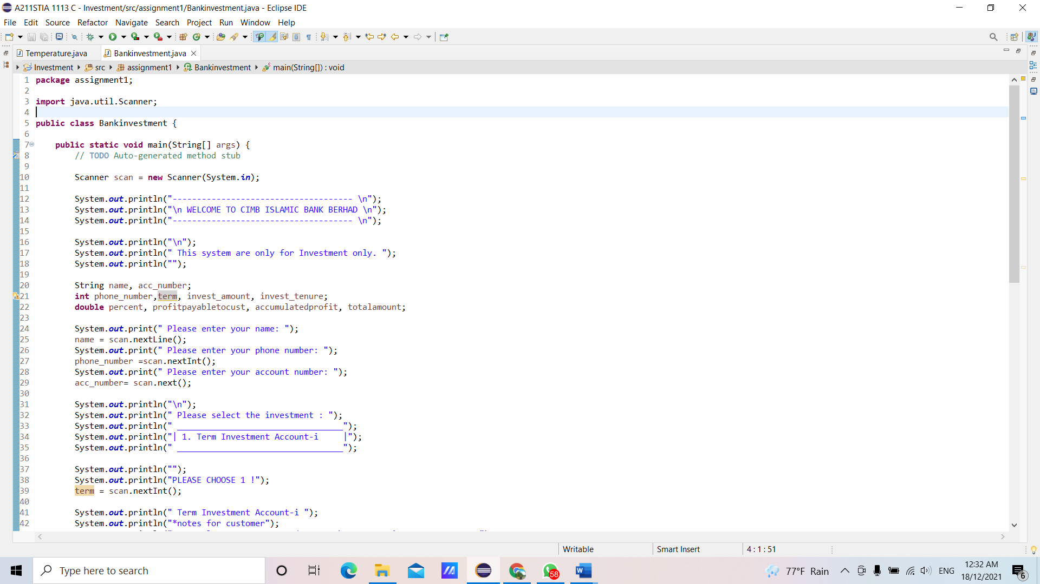

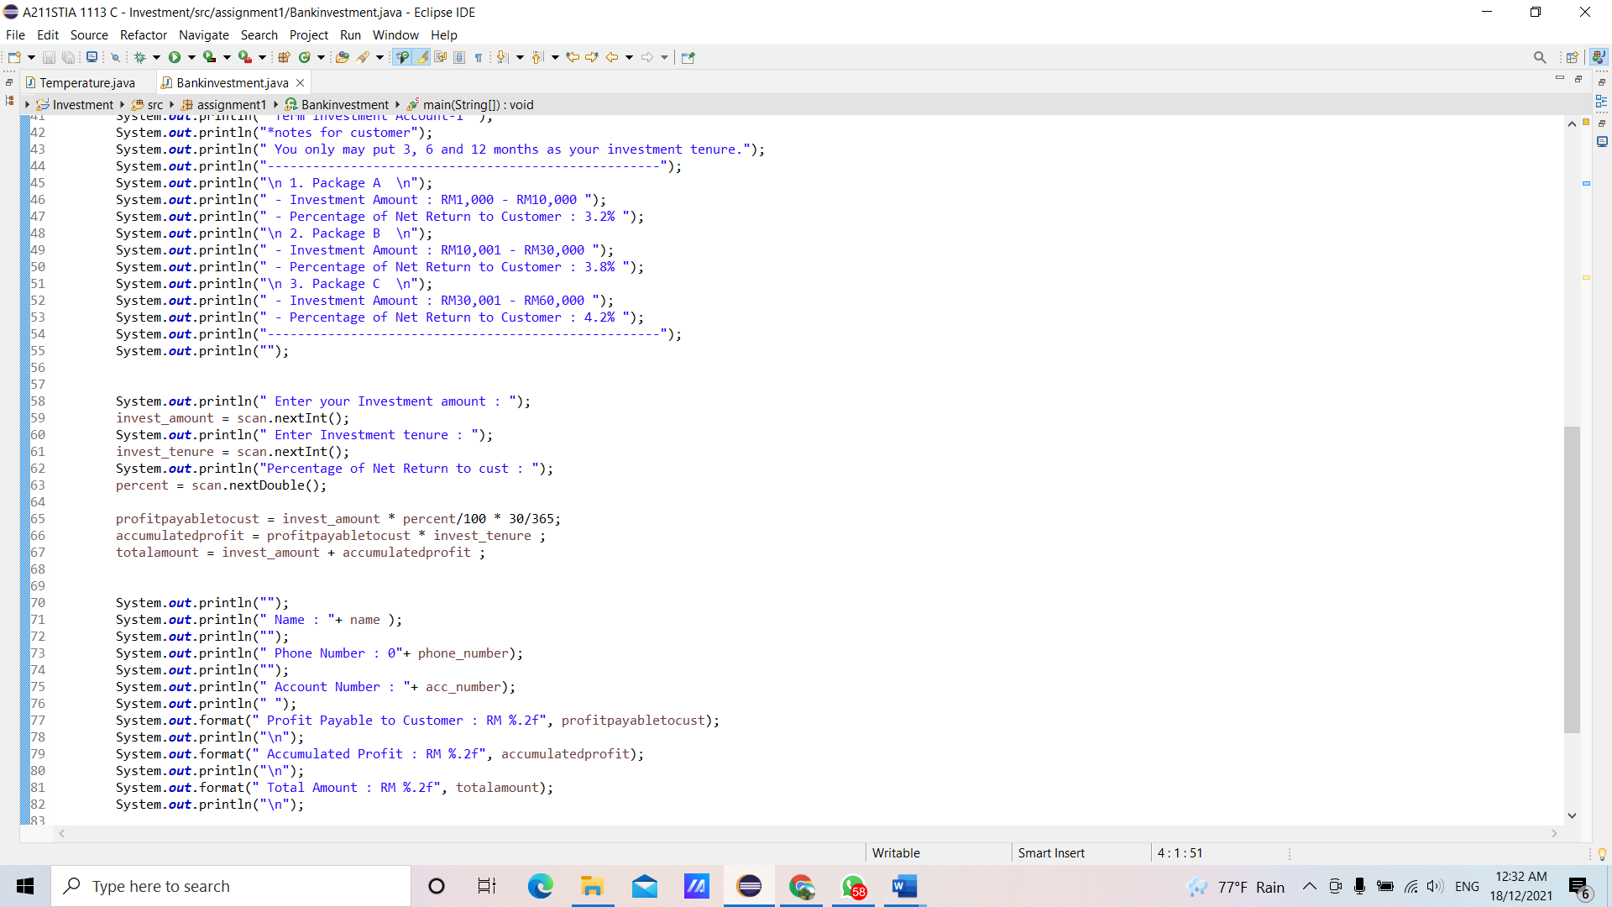

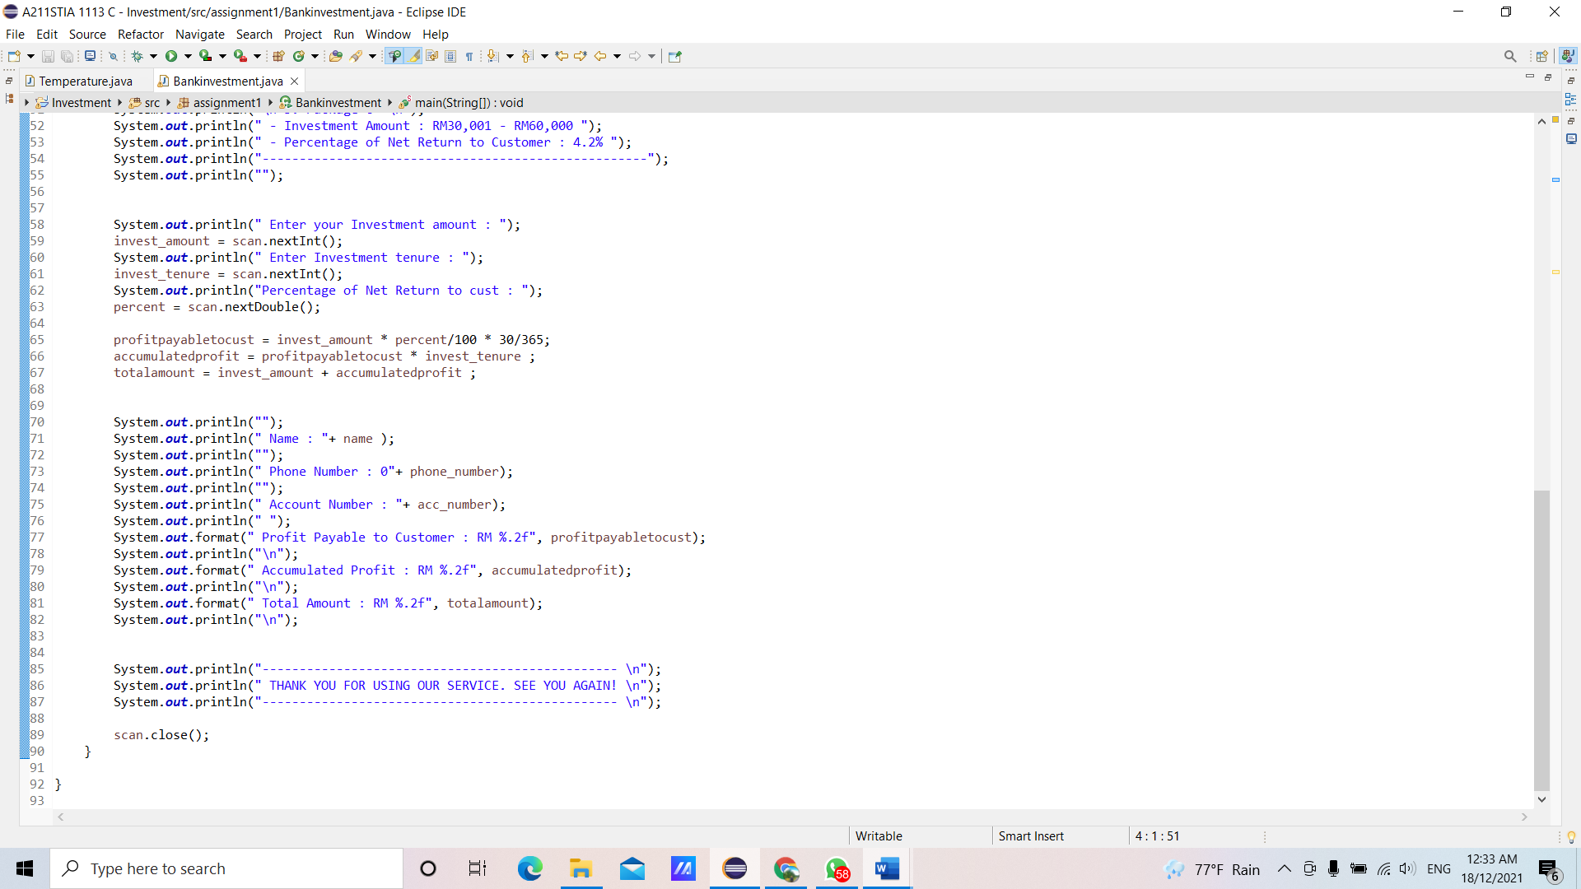

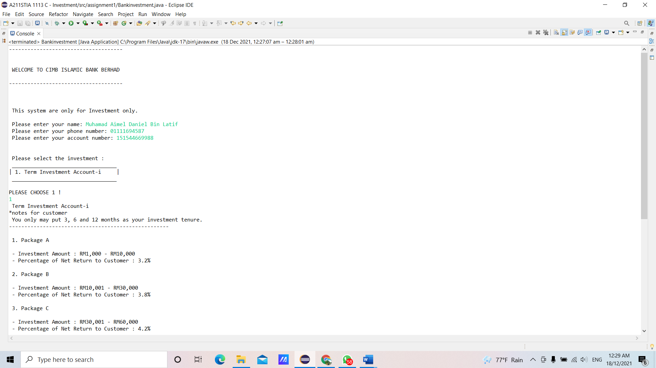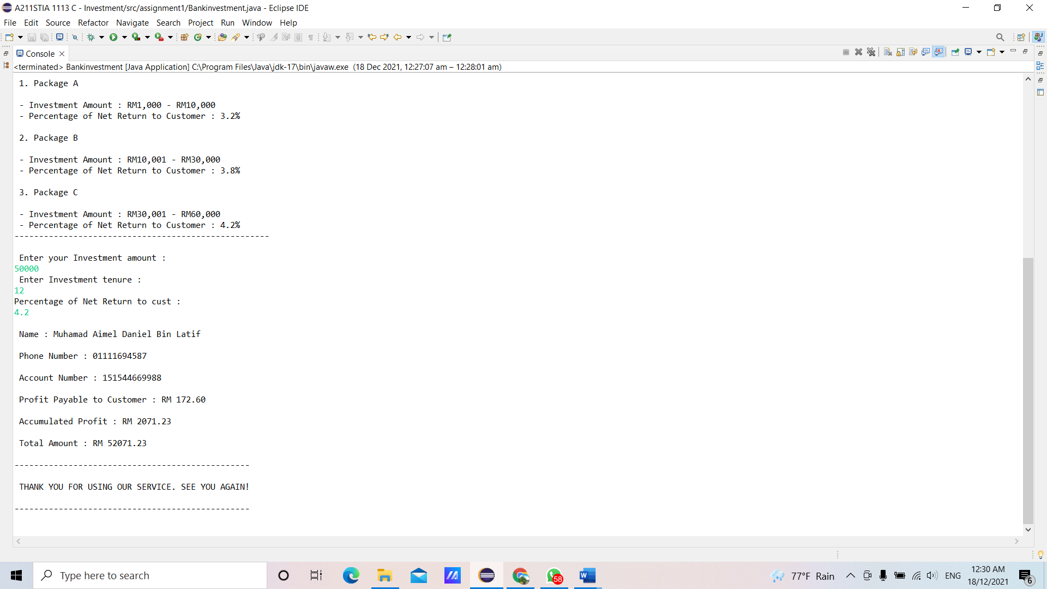

**References:**

1. CIMB Investment. Retrieved from https://www.cimb.com.my/en/personal/day-to-day-banking/investments.html
2. Adam Hayes. (2021, August, 20). *Investment. What is an Investment?* Retrieved from https://www.investopedia.com/terms/i/investment.asp
3. Siwe Geck, Kwang Hooi, Zaliha & Fatimah. (2016) *SAINS KOMPUTER TINGKATAN 4.* Oxford Fajar Sdn. Bhd.